Creating Platform Library In spring boot
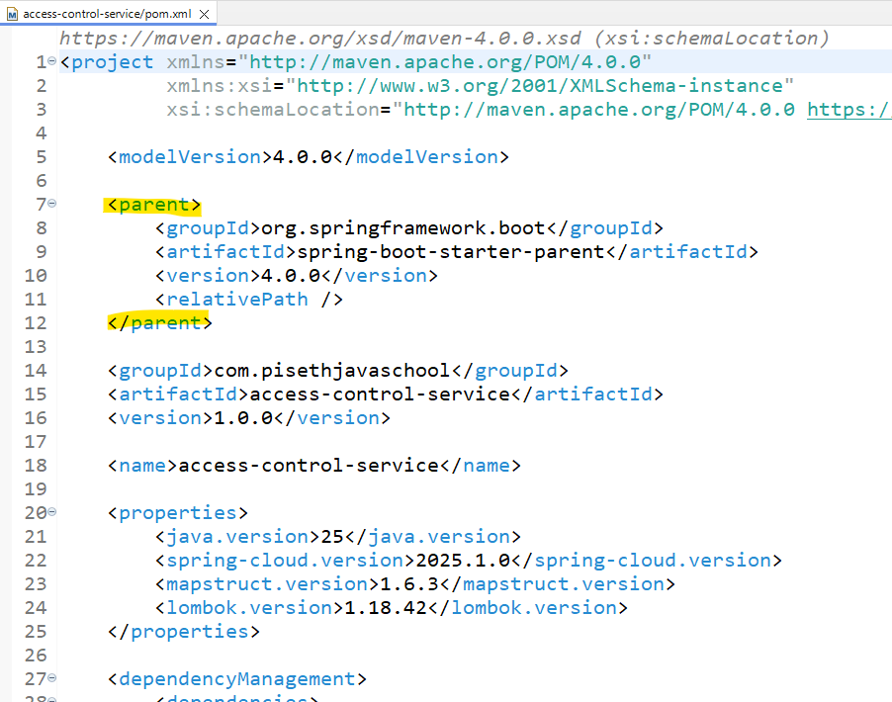

- Normal project in the pom.xml

<parent>
<groupId>org.springframework.boot</groupId>
<artifactId>spring-boot-starter-parent</artifactId>
<version>4.0.0</version>
<relativePath />
</parent>

- What we can get from access-control project to create platform library :

  - AuditableEntity ( ចឹងកន្លែងនឹងវាជា candidate មួយហើយដែលយើងត្រូវធ្វើការ move វាចេញ) កន្លែងនឹងសម្រាប់ធ្វើ Auto
  - package com.pisethjavaschool.accesscontrol.common.exception: តាមក្រុមហ៊ុនមួយៗវាមាន កន្លែងដែល handle exception ចឹងកន្លែងនឹងយើងត្រូវដាក់វាមួយដុំដែលដើម្បីស្រួលធ្វើការ import ចូល
  - package com.pisethjavaschool.accesscontrol.common.security; ផ្នែក security
  - package com.pisethjavaschool.accesscontrol.common.web ផ្នែក filter
  - package com.pisethjavaschool.accesscontrol.common.openapi; API Swager

របៀបបង្កើត Library បង្កើត multi module project
- platform-common
- platform-exception
- platform-openapi

(edb: Enterprise development)

យើងធ្វើការ extract វាជា Module ហើយបង្កើតវាជា Jar file ដាក់ចូល Project ដោយ add dependency to the project ដែលយើងចង់ហៅវាមកប្រើប្រាស់នឹង

- Creating parent project

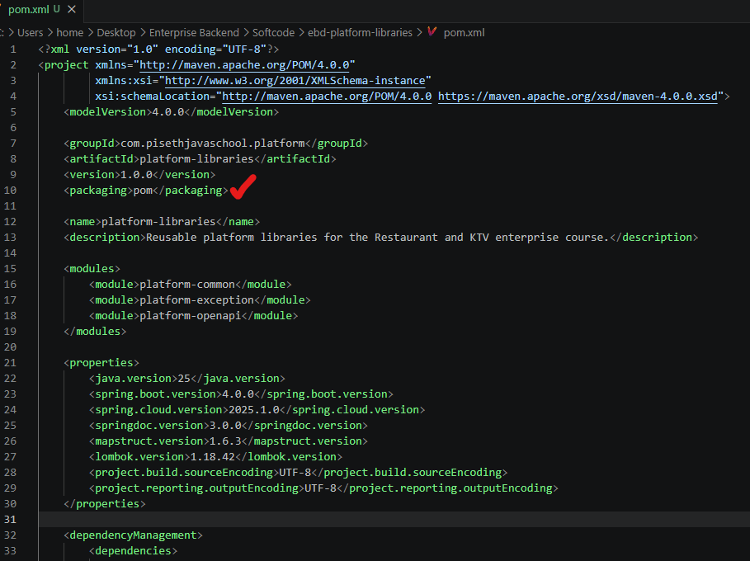

- យើងដាក់ package វាជា pom ដោយសារតែយើងបង្កើតវាជា parent project ហើយបានធ្វើការ add dependency platform យើងមួយៗចូល (it is the base file)

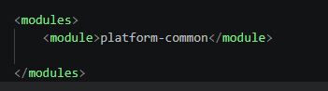
- កន្លែងដែលយើងអាចដាក់ Module យើងចូល

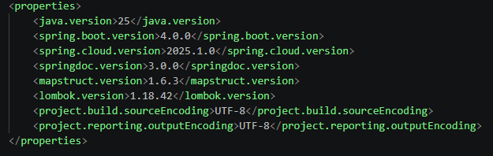
- យើងអាចធ្វើការ define កំណត់ទៅលើ Version ផ្សេងៗ បាននៅក្នុង Pom project នឹង ដើម្បីអោយ Children វាចឹងដែល easy to control

- កន្លែង Dependency management សម្រាប់កំណត់អោយ Child ប្រើប្រាស់ Version ឬ ដើម្បីអោយ sub module ប្រើ version នឹង
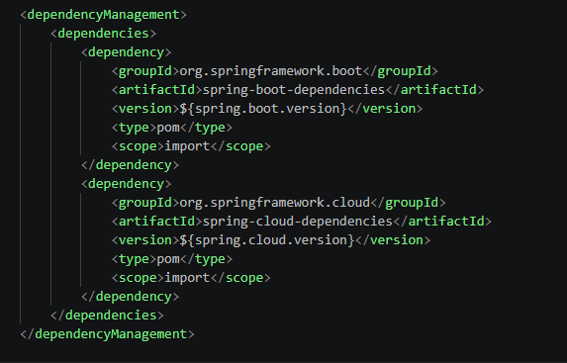

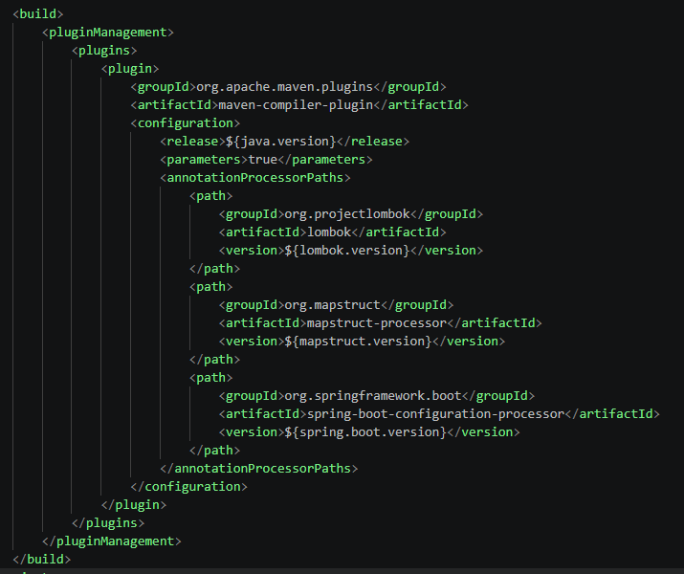
- Plugin សម្រាប់ add feature ទៅតាម decency នីមួយៗ នឹង

Code:

<?xml version="1.0" encoding="UTF-8"?>
<project xmlns="http://maven.apache.org/POM/4.0.0"
xmlns:xsi="http://www.w3.org/2001/XMLSchema-instance"
xsi:schemaLocation="http://maven.apache.org/POM/4.0.0 https://maven.apache.org/xsd/maven-4.0.0.xsd">
<modelVersion>4.0.0</modelVersion>

<groupId>com.pisethjavaschool.platform</groupId>
<artifactId>platform-libraries</artifactId>
<version>1.0.0</version>
<packaging>pom</packaging>

<name>platform-libraries</name>
<description>Reusable platform libraries for the Restaurant and KTV enterprise course.</description>

<modules>
<module>platform-common</module>

</modules>

<properties>
<java.version>25</java.version>
<spring.boot.version>4.0.0</spring.boot.version>
<spring.cloud.version>2025.1.0</spring.cloud.version>
<springdoc.version>3.0.0</springdoc.version>
<mapstruct.version>1.6.3</mapstruct.version>
<lombok.version>1.18.42</lombok.version>
<project.build.sourceEncoding>UTF-8</project.build.sourceEncoding>
<project.reporting.outputEncoding>UTF-8</project.reporting.outputEncoding>
</properties>

<dependencyManagement>
<dependencies>
<dependency>
<groupId>org.springframework.boot</groupId>
<artifactId>spring-boot-dependencies</artifactId>
<version>${spring.boot.version}</version>
<type>pom</type>
<scope>import</scope>
</dependency>
<dependency>
<groupId>org.springframework.cloud</groupId>
<artifactId>spring-cloud-dependencies</artifactId>
<version>${spring.cloud.version}</version>
<type>pom</type>
<scope>import</scope>
</dependency>
</dependencies>
</dependencyManagement>

<build>
<pluginManagement>
<plugins>
<plugin>
<groupId>org.apache.maven.plugins</groupId>
<artifactId>maven-compiler-plugin</artifactId>
<configuration>
<release>${java.version}</release>
<parameters>true</parameters>
<annotationProcessorPaths>
<path>
<groupId>org.projectlombok</groupId>
<artifactId>lombok</artifactId>
<version>${lombok.version}</version>
</path>
<path>
<groupId>org.mapstruct</groupId>
<artifactId>mapstruct-processor</artifactId>
<version>${mapstruct.version}</version>
</path>
<path>
<groupId>org.springframework.boot</groupId>
<artifactId>spring-boot-configuration-processor</artifactId>
<version>${spring.boot.version}</version>
</path>
</annotationProcessorPaths>
</configuration>
</plugin>
</plugins>
</pluginManagement>
</build>
</project>

- We can import them to our IDE (Import pom.xml)
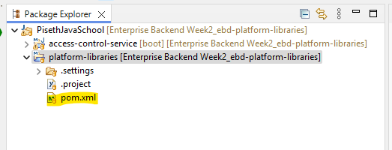

- We build the platform command
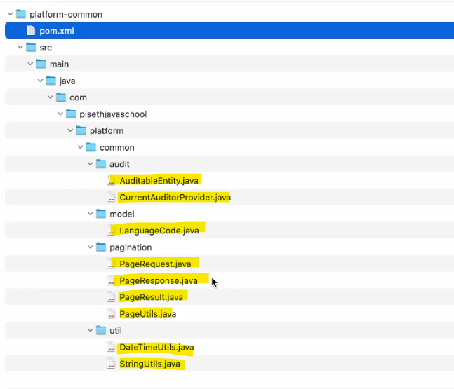

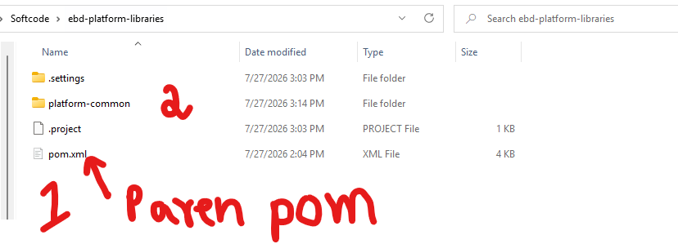

- យើងយក platform-common មកដាក់ចូលក្នុង Folder “pom” parent (សំខាន់យើងមើលឈ្មោះរបស់ វាអោយត្រូវទៅនឹងអ្វីដែលយើង ចង់ដាក់ចូលនឹង)​
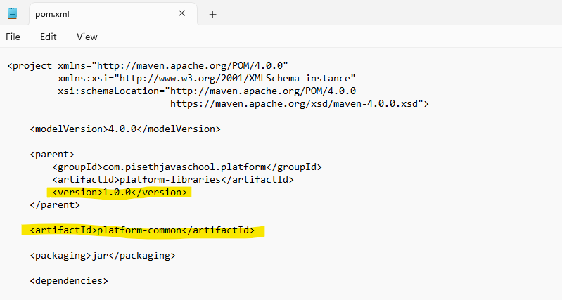

- ហើយយើងត្រូវដាក់ packaging វាជា jar file ព្រោះយើងយកវាមកប្រើ
ចឹងយើងត្រូវធ្វើការ Import វាជា Project ម្តងទៀតទើបយើងអាចធ្វើការ create jar file វាបាន
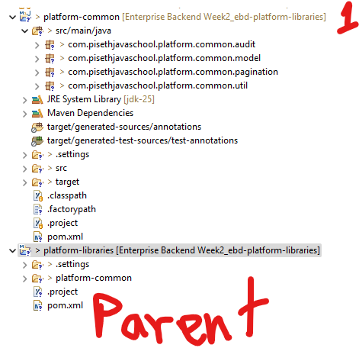

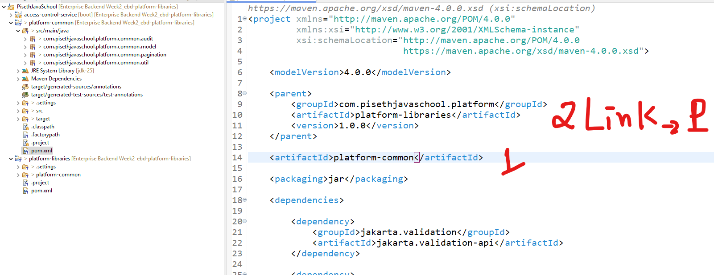
- inside the pom.xml for the palatform-common :

Build the Library from the parent file
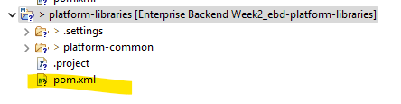

>> mvn clean install

We use the mvn clean install ដើម្បីធ្វើការ បង្កើត Jar file ហើយដាក់វាចូលទៅក្នុង Local repository .m2
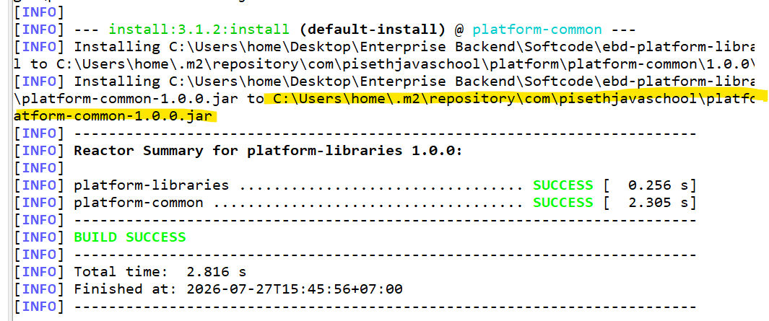

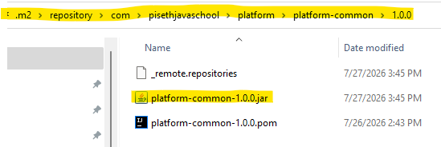

- Import the jar file to the project

Add the dependance:
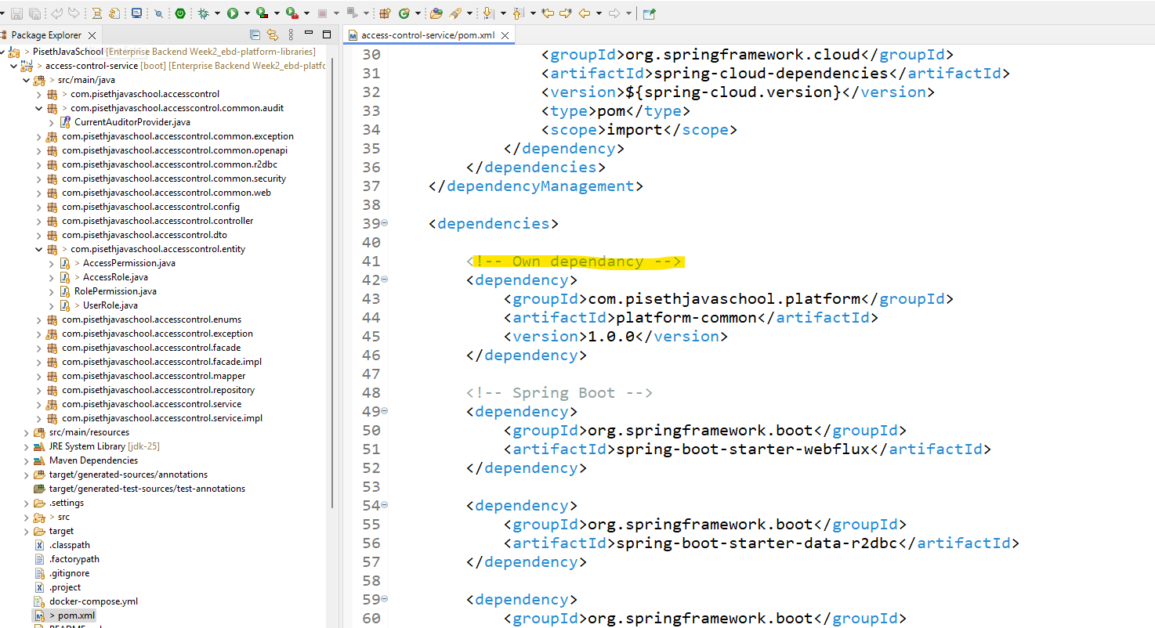

<dependency>
<groupId>com.pisethjavaschool.platform</groupId>
<artifactId>platform-common</artifactId>
<version>1.0.0</version>
</dependency>
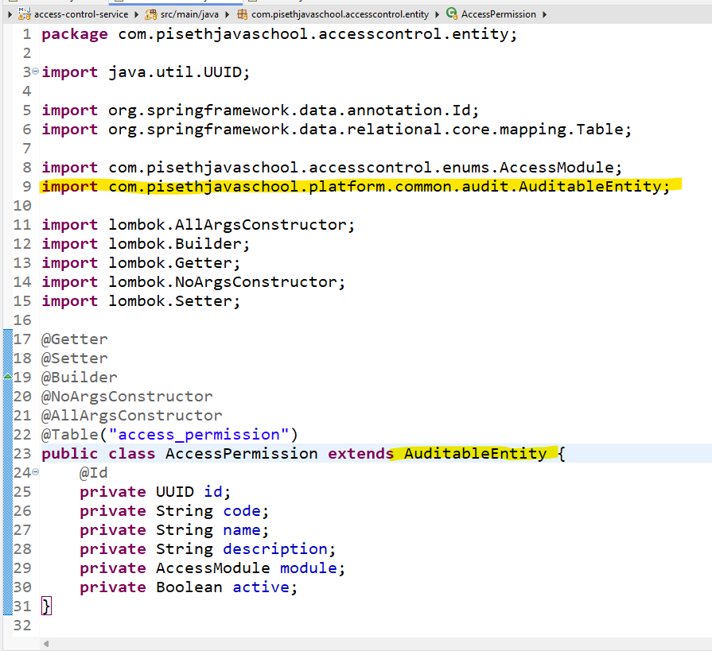

- In the class we can import teams from our package

Import Exception

- Add platform exception

- Import exception to STS: ដើម្បីធ្វើការ compiler creates jar file to the .me (our local repository). And Import openapi to STS.
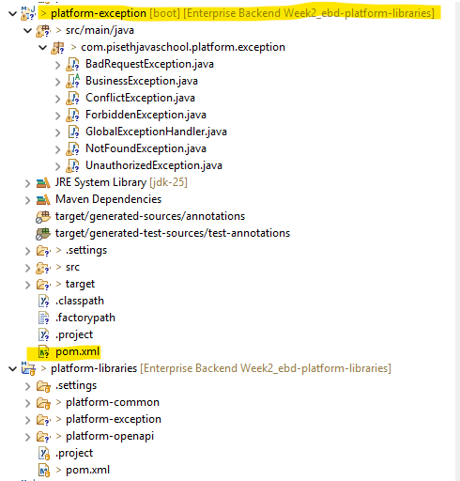
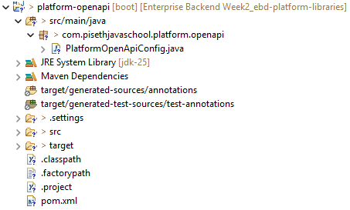

- In the pom.xml (parent): ដើម្បីអោយវាយក dependency from parent class
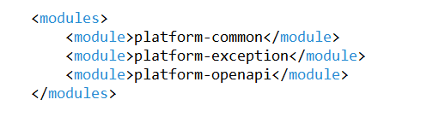

- Where we want to use the library, we can add the dependency
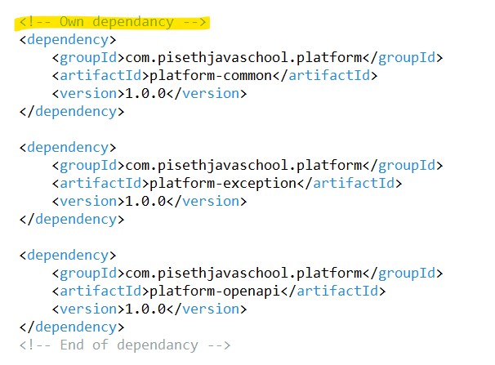

- Testing api class
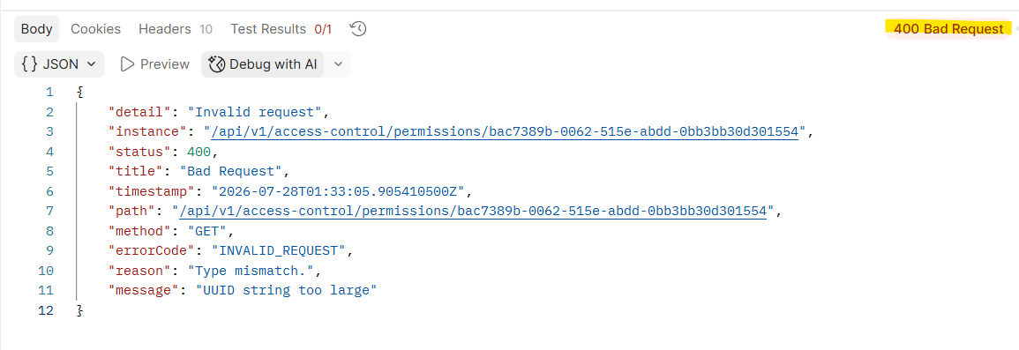

- We can check the implementation from the getById
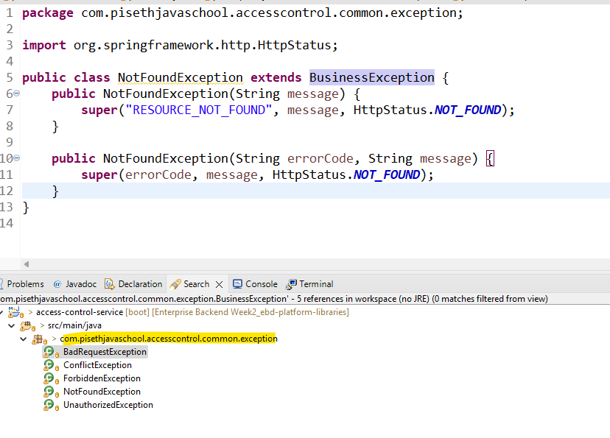

កន្លែងនឹងមានន័យថា វាចាប់យក Package from their local package so we can deleted it the whold exception from the class. យើងប្តូរ Package វាដាក់ទៅកាន់ Pacakge flatform យើងវិញ។
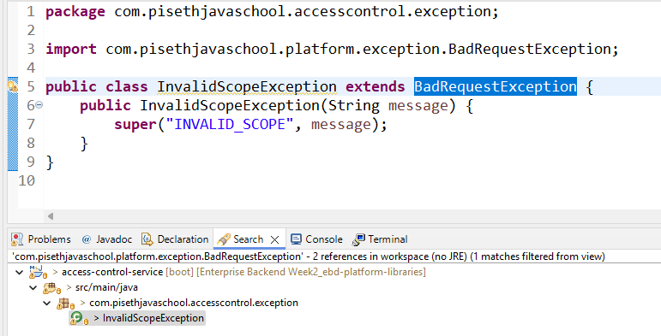

- Replace swager from our flatform
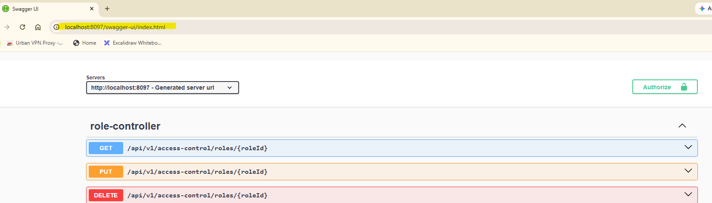

- We just add the dependencies from the platform tov ban hery
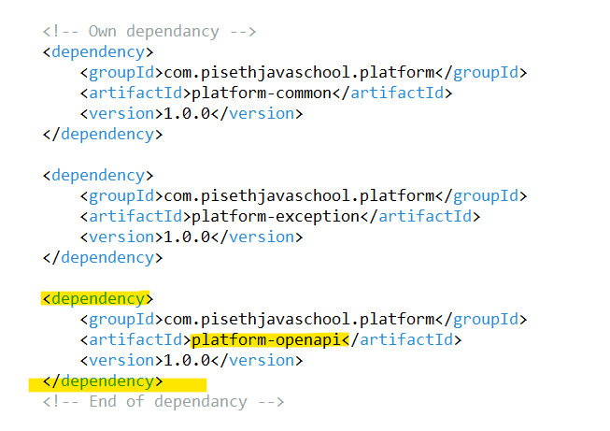

- Then it will working for thw openapi swager

